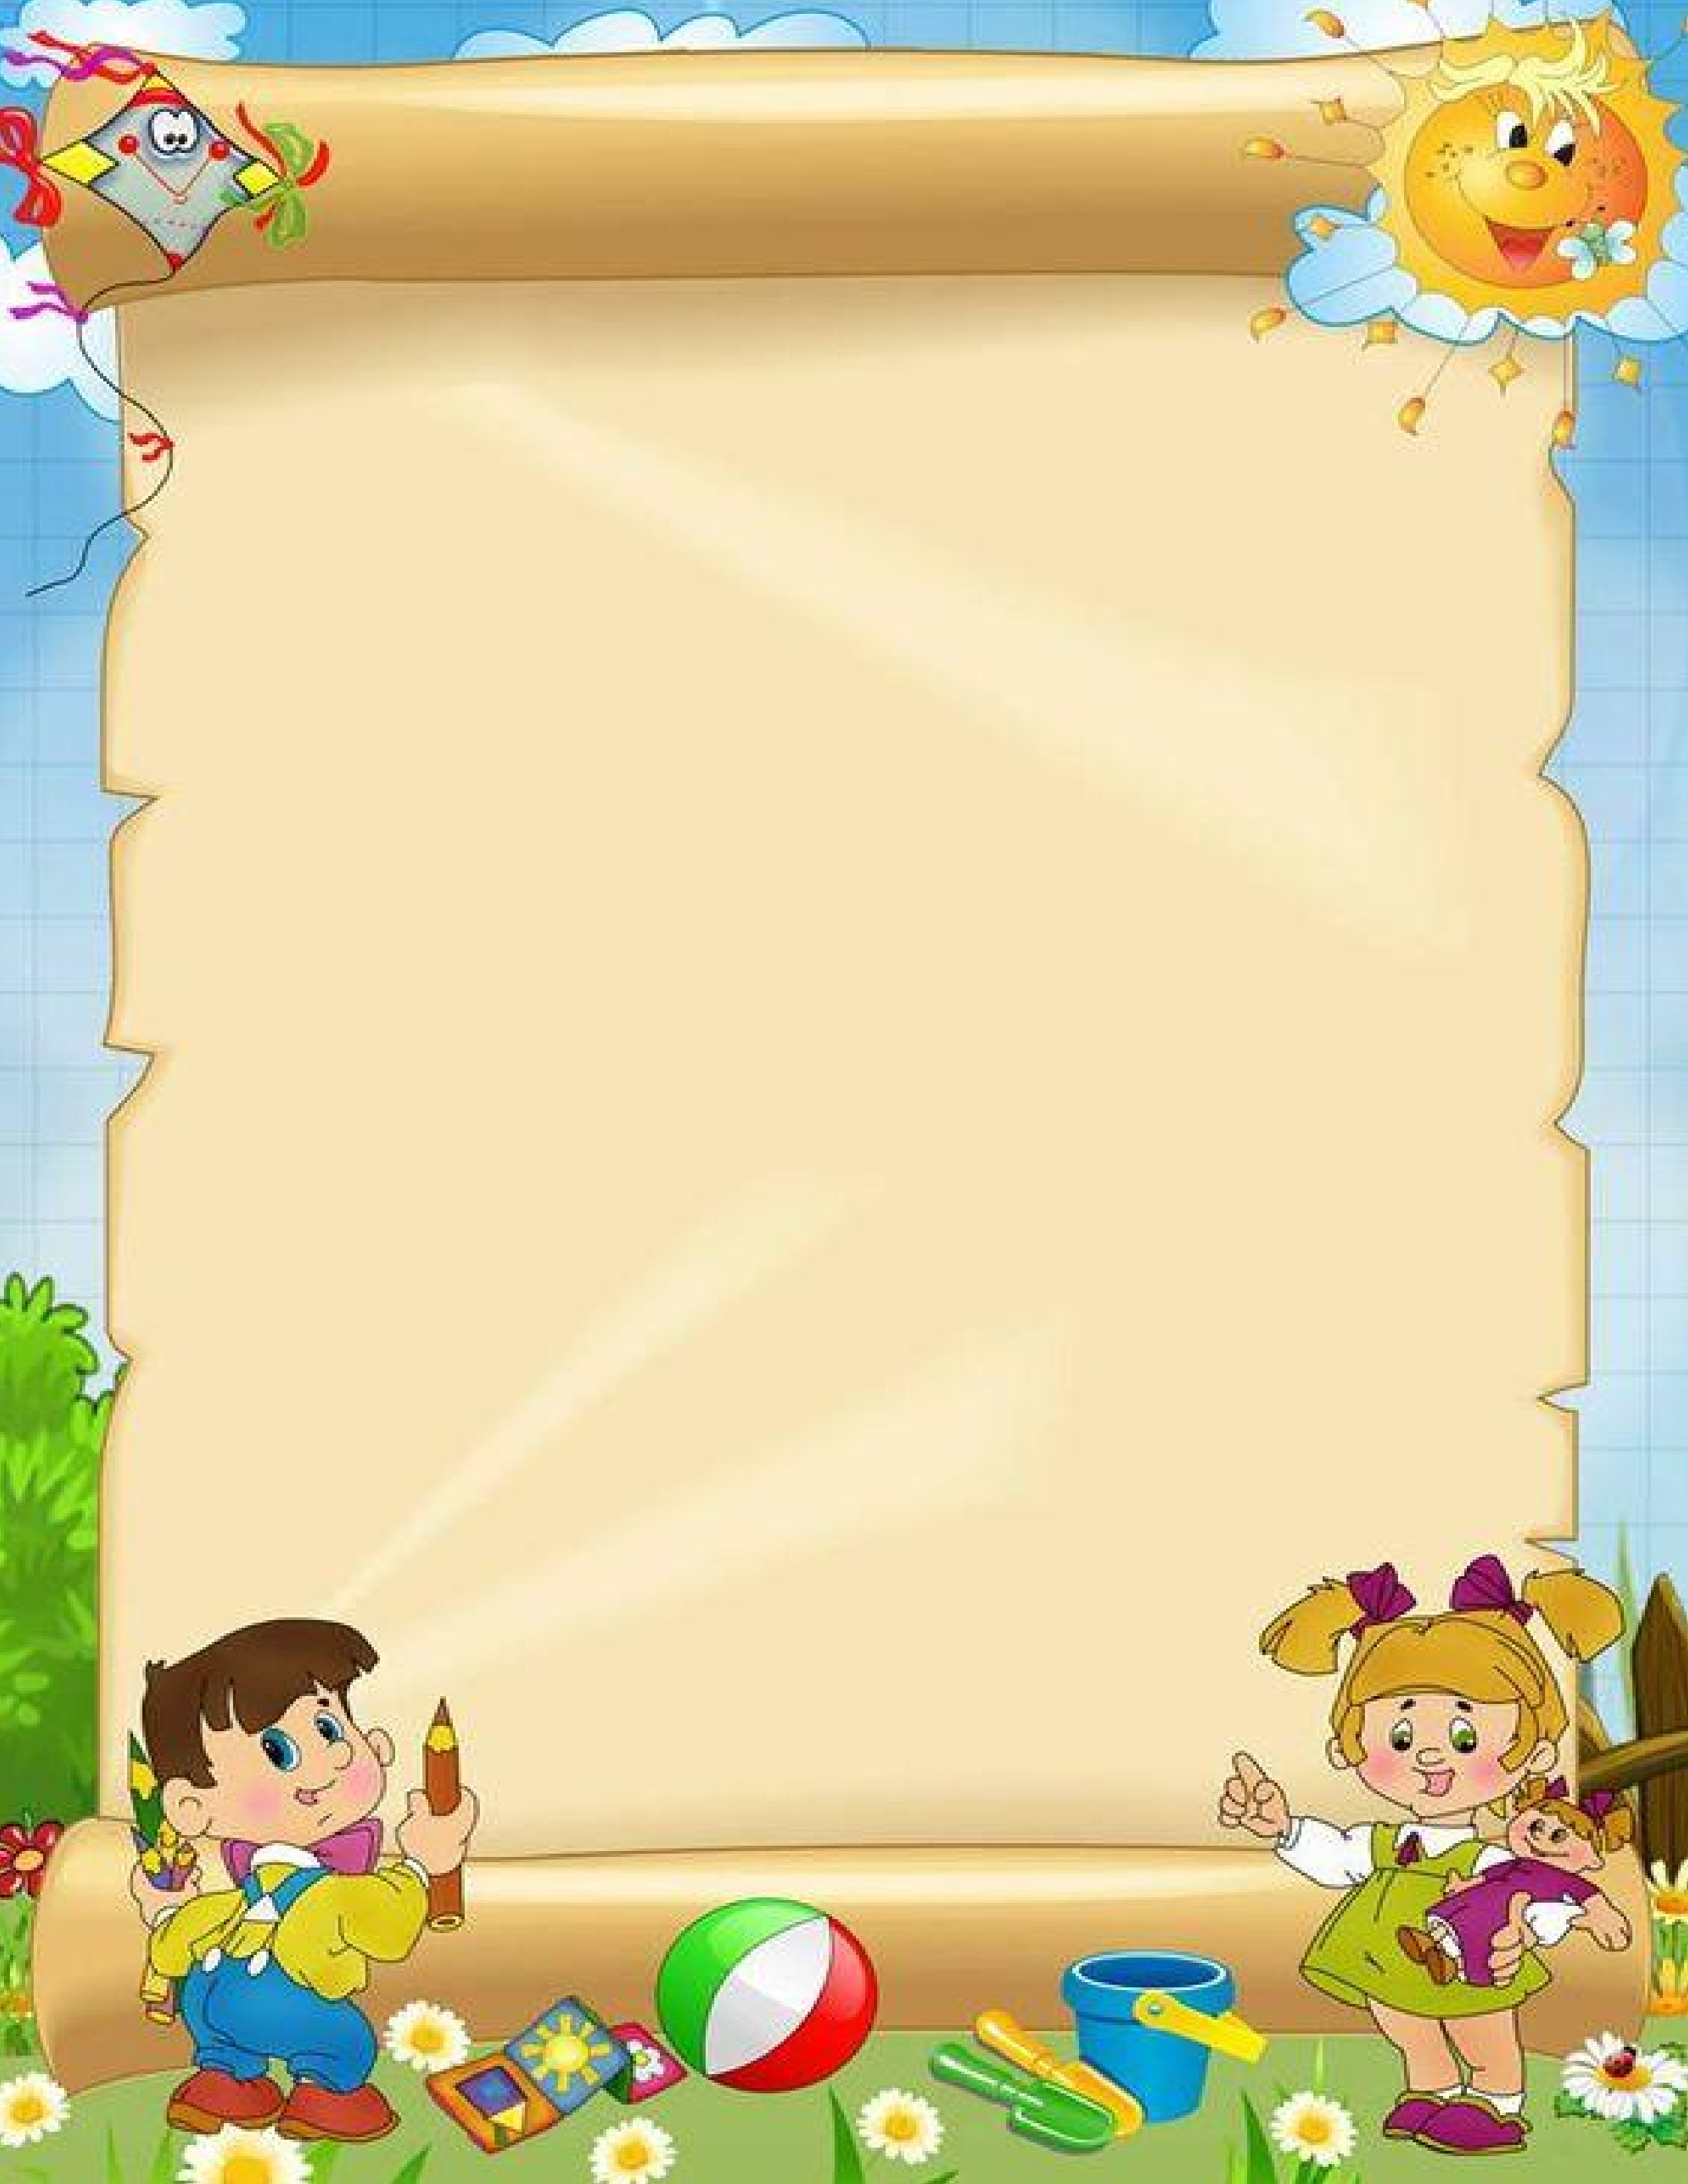

**MILLENNIUM WORLD SCHOOL**

**PATNA**

NAME:___________________________________________________

**JUNIOR KG**

SUMMER

HOLIDAY

WORKSHEETS

* Kindly send the worksheets on the first working day, after the vacation, for correction.
* All work is to be done in the worksheet itself.



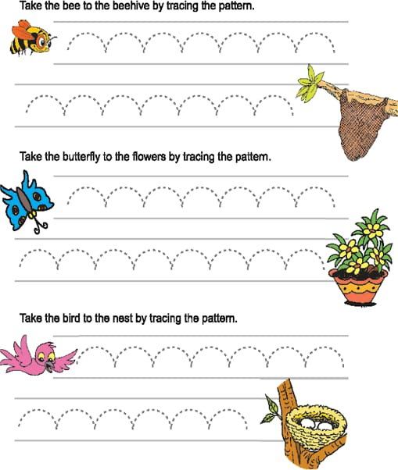

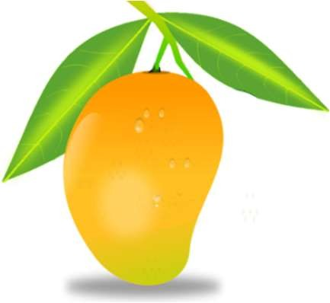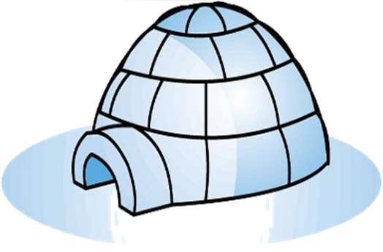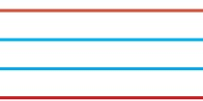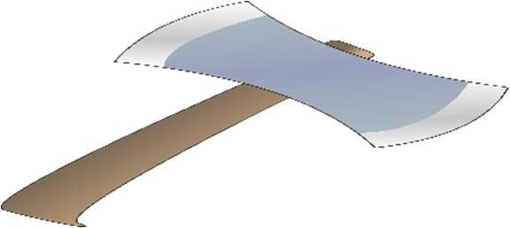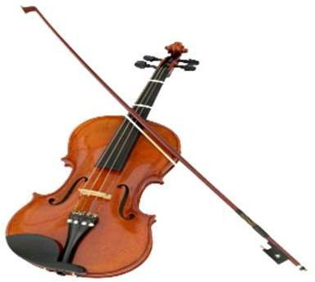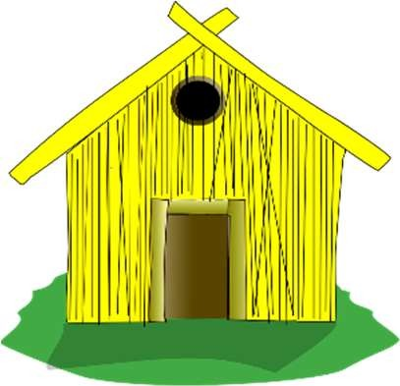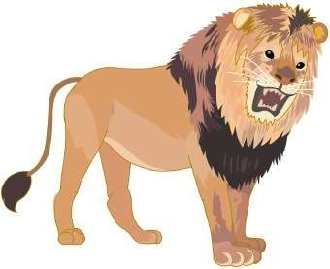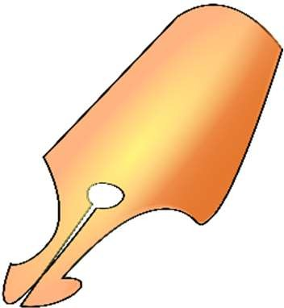

**स्वर और व्यंजन लिखें:**



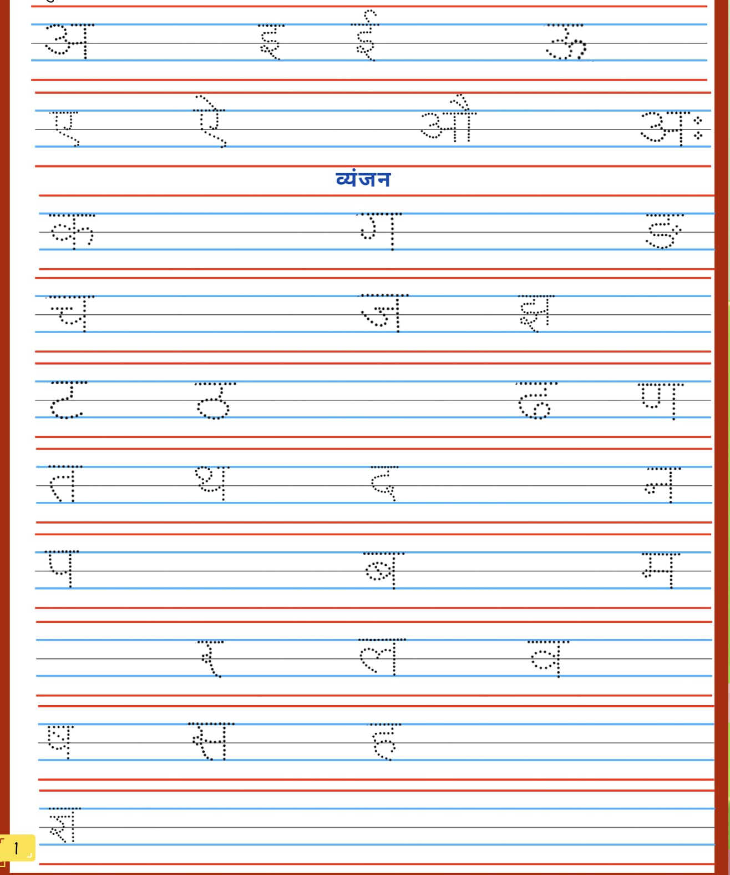

***Write the first letter of the pictures:***



**Circle the correct first letter for the given pictures:**

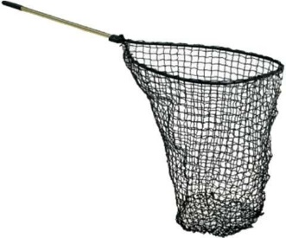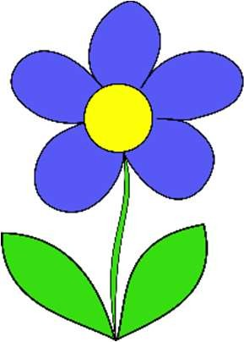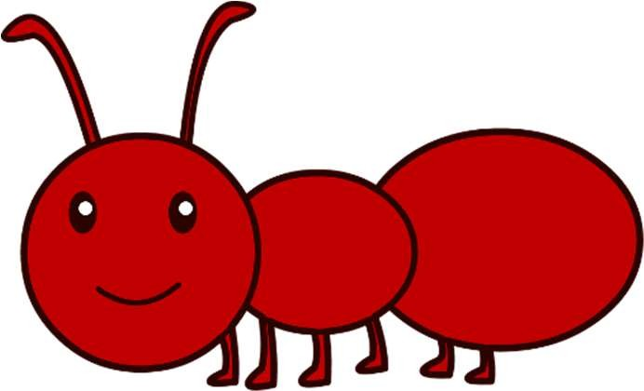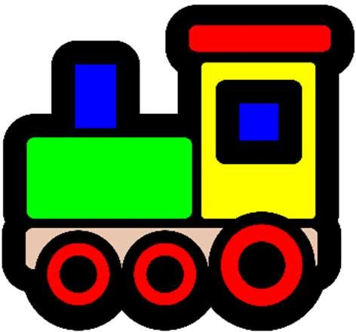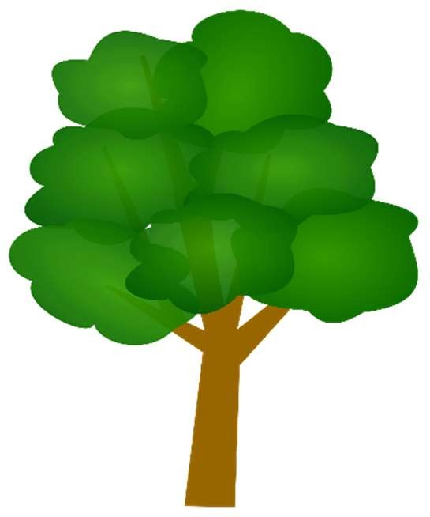

# H N F A M F

**T M L V H E**

# H A I M N E

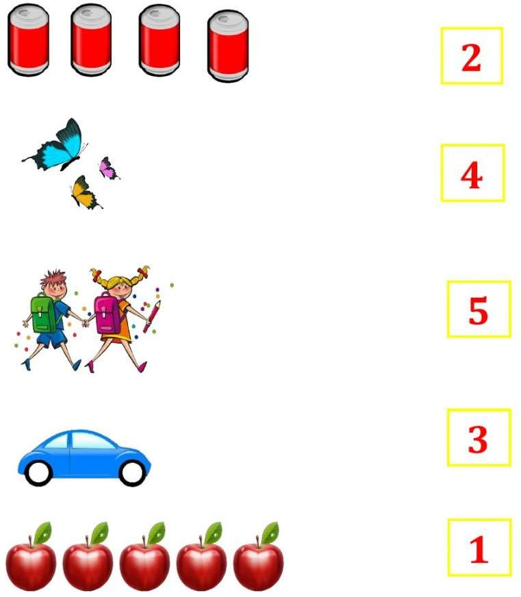**I can count and match:**

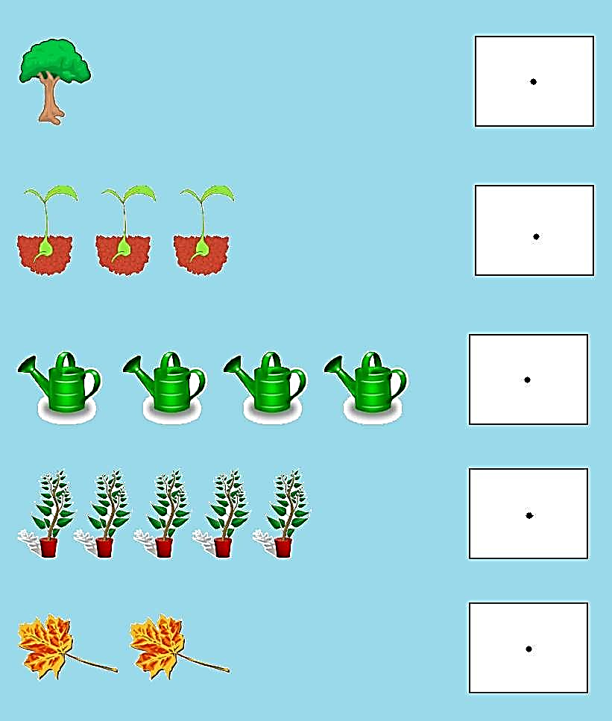**Count and write the number:**



**Colour the Big Picture:**

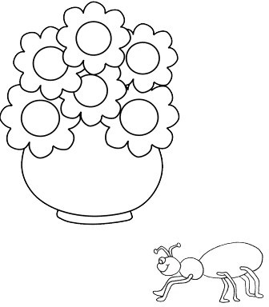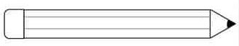

**Colour the Long Pencil Light Green and Short Pencil Blue:**

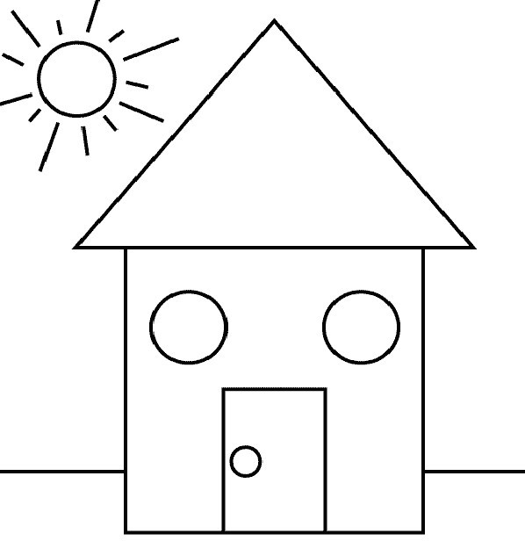**Colour the Circle Shaped Objects Yellow and Square shaped objects Pink and Triangle Shaped Objects Orange and Rectangle shaped objects Green.**

 **BODY PARTS**

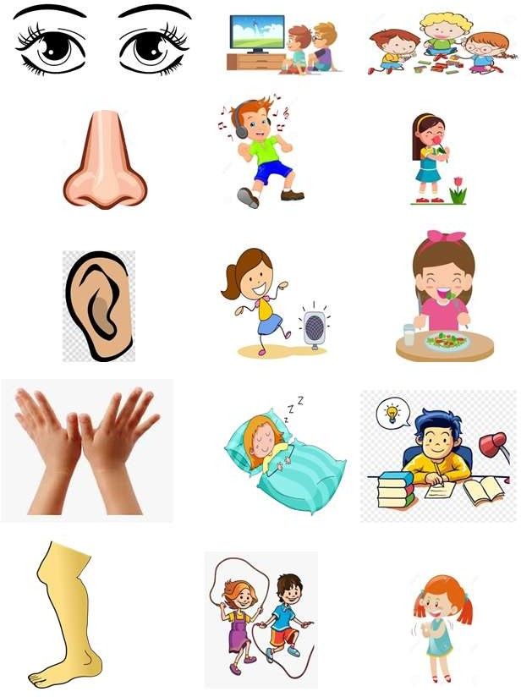**Circle the functions of the body parts**